1t.
Make Transaction
- Pub-priv generated
  - choose supported EC curve name and generate key pair
  - a private key in standard format is simply a 256-bit number, between the values:0x01 and 0xFFFF FFFF FFFF FFFF FFFF FFFF FFFF FFFE BAAE DCE6 AF48 A03B BFD2 5E8C D036 4140, representing nearly the entire range of 2256-1 values. The range is governed by the secp256k1 ECDSA encryption standard used by Bitcoin.
  - Private keys are always 32 bytes, and public keys are always 65 bytes (or 33 bytes for a compressed public key). Public key hashes are always 20 bytes.
- Pub key hash
  - PKHash=HASH160(PK)=RIPEMD160(SHA256(PK))
- Create Address
  - https://en.bitcoin.it/wiki/Technical_background_of_version_1_Bitcoin_addresses#How_to_create_Bitcoin_Address
  - https://i.stack.imgur.com/AcXYt.png
  - 4checksumBytes=first4(SHA256(SHA256(00|PKHash)))
  - Address=Base58(00|PKHash|4checksumBytes)
https://bitcoin.org/en/developer-guide#p2pkh-script-validation

Test Create Address 1.
Private-
a2d43efac7e99b7e3cf4c07ebfebb3c349d8f2b5b0e1062d9cef93c170d22d4f
Public - 0427d64b2de9f51ac1bf6b287088de3afcf67e8dd820848128cc27f71c18c5f8baefe71cc14052b4989e33a17f4795022f70313561cb3ef3d0b599c49933daa6fd
3.
SHA256(Public) http://www.fileformat.info/tool/hash.htm 32 Bytes
f6c4d6736f912ffebe65fb1497aac2a111d037883f39b5d72ea0d39f216ed368
RIPEMD160(SHA256(PK))
f3cd5ddd30ad4d28f13cf195786f2e95e8914b22
(Check: HASH160 func gives address from pk http://bitcoinvalued.com/tools.php Base58Decode(HASH160).toLowerCase=00||RIPEMD160(SHA256(PK))-last4
1PE7Djw8d1RthCXNwyYYNBv89mmgVezsvy )
2.
1 - Having a private ECDSA key Take the corresponding public key generated with it (65 bytes, 1 byte 0x04, 32 bytes corresponding to X coordinate, 32 bytes corresponding to Y coordinate)
2 - Perform SHA-256 hashing on the public key
3 - Perform RIPEMD-160 hashing on the result of SHA-256
4 - Add version byte in front of RIPEMD-160 hash (0x00 for Main Network) 00f3cd5ddd30ad4d28f13cf195786f2e95e8914b22
(note that below steps are the Base58Check encoding, which has multiple library options available implementing it)
5 - Perform SHA-256 hash on the extended RIPEMD-160 result
9c618e84ba7bb0b6d208f7f57d9b92bdfb929efba53a3668469115a96105db90
6 - Perform SHA-256 hash on the result of the previous SHA-256 hash
5c8492ba9c962bd90185764df1d68e106828d9608ebd42a81280e3d7ba7f41f7
7 - Take the first 4 bytes of the second SHA-256 hash. This is the address checksum
5c8492ba
8 - Add the 4 checksum bytes from stage 7 at the end of extended RIPEMD-160 hash from stage 4. This is the 25-byte binary Bitcoin Address.
00f3cd5ddd30ad4d28f13cf195786f2e95e8914b225c8492ba
9 - Convert the result from a byte string into a base58 string using Base58Check encoding. This is the most commonly used Bitcoin Address format http://lenschulwitz.com/base58
1PE7Djw8d1RthCXNwyYYNBv89mmgVezsvy

Test Create 2 using example transaction.
PKhash - bcadb700c24da04b17feb9aa9bd71e368a4b623c
Address - 1JCe8z4jJVNXSjohjM4i9Hh813dLCNx2Sy
  - 4checksumBytes=first4(SHA256(SHA256(00|PKHash)))
dc40e08e9af8fd6bb0a8ea46839a96e871a9a5ef3aae91a4b4802c2076aaa1f2
dc40e08e
  - Address=Base58(00|PKHash|4checksumBytes)
00bcadb700c24da04b17feb9aa9bd71e368a4b623cdc40e08e
1JCe8z4jJVNXSjohjM4i9Hh813dLCNx2Sy
RipeMD160 description
https://rosettacode.org/wiki/RIPEMD-160#FreeBASIC
http://homes.esat.kuleuven.be/~bosselae/ripemd160/pdf/AB-9601/AB-9601.pdf
https://www.esat.kuleuven.be/cosic/publications/article-317.pdf
http://crypto.stackexchange.com/questions/32400/how-does-ripemd160-pad-the-message
http://www.slideshare.net/TazoAl1/hash-49022010
https://github.com/dlitz/pycrypto/blob/master/src/RIPEMD160.c
http://people.chu.edu.tw/~chlee/Crypto/Crypto9_1p.pdf
http://stackoverflow.com/questions/2124165/what-is-wrong-with-my-ripemd160-python-code
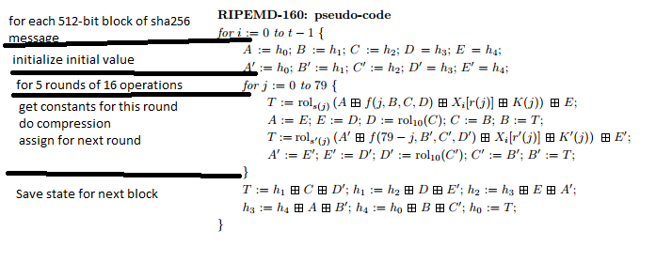

Sign Transaction
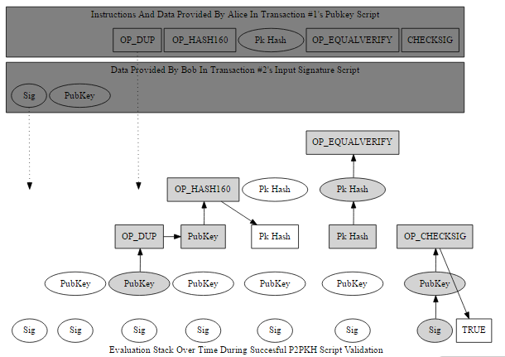
- Signature generated
https://en.wikipedia.org/wiki/Elliptic_Curve_Digital_Signature_Algorithm
https://en.bitcoin.it/wiki/Secp256k1
curve E: y² = x³+7
The base point G in compressed form is:
- G = 02 79BE667E F9DCBBAC 55A06295 CE870B07 029BFCDB 2DCE28D9 59F2815B 16F81798
and in uncompressed form is:
- G = 04 79BE667E F9DCBBAC 55A06295 CE870B07 029BFCDB 2DCE28D9 59F2815B 16F81798 483ADA77 26A3C465 5DA4FBFC 0E1108A8 FD17B448 A6855419 9C47D08F FB10D4B8
Finally the order n of G and the cofactor are:
- n = FFFFFFFF FFFFFFFF FFFFFFFF FFFFFFFE BAAEDCE6 AF48A03B BFD25E8C D0364141
- h = 01

  - Key creation
private key integer d_A, randomly selected in the interva [1,n-1]; and a public key curve point Q_A=d_A x G. We use x to denote elliptic curve point multiplication by a scalar http://crypto.stackexchange.com/questions/3907/how-does-one-calculate-the-scalar-multiplication-on-elliptic-curves
http://www.righto.com/search?q=bitcoin
https://github.com/shirriff/bitcoin-code
  - Message to be signed? TXCopy.serialize() https://en.bitcoin.it/wiki/OP_CHECKSIG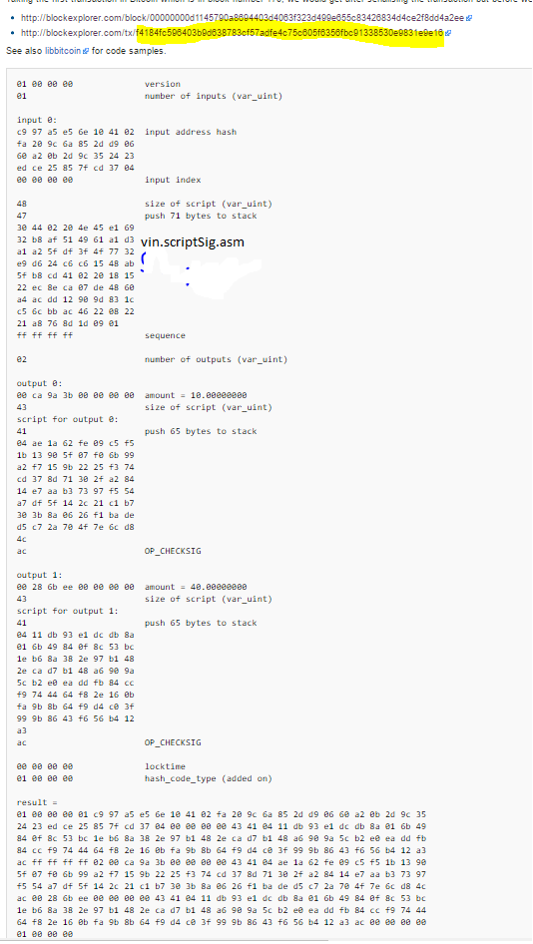
  - message=result
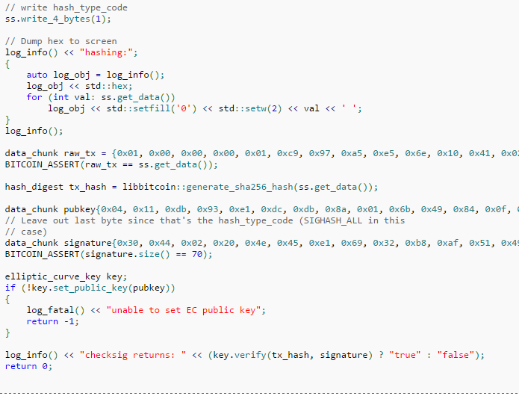

  - http://bitcoin.stackexchange.com/questions/37093/what-goes-in-to-the-message-of-a-transaction-signature
scriptPubKey.hex 76a914bcadb700c24da04b17feb9aa9bd71e368a4b623c88ac
  - e=SHA256(m)
  - Let z be the L_n leftmost bits of e, where L_n is the bit length of the group order n
  - Select a cryptographically secure random integer k from [1,n-1]
  - Calculate the curve point (x_{1},y_{1})=k x G.
  - Calculate r=x_1 mod n. If r=0 go back to step e.
  - Calculate s=k^{-1}*(z+r*d_A) mod n. If s=0 go back to step e.
  - The signature is the pair (r,s)

Verify signature
For Bob to authenticate Alice's signature, he must have a copy of her public-key curve point Q_A Bob can verify Q_A is a valid curve point as follows:
- Check that Q_A is not equal to the identity element O, and its coordinates are otherwise valid
- Check that Q_A lies on the curve
- Check that Q_A=O
After that, Bob follows these steps:
- Verify that r and s are integers in [1,n-1]. If not, the signature is invalid.
- Calculate e=SHA256(m)
  - ECDSA_CheckSignature(pubkeyStr,SigStr,sha256(sha256(m)))?
- Let z be the L_n leftmost bits of e.
- Calculate w=s^{-1} mod n
- Calculate u_1=zw mod n and u_2=rw mod n.
- Calculate the curve point (x_1,y_1)=u_1 x G + u_2 x Q_A.
- The signature is valid if r === x_1 mod n, invalid otherwise.

Example transaction
https://chainquery.com/bitcoin-api/getrawtransaction/99dbfd52265ee86d46d3802d2ee2cdf70600896d8fa923c5f5236abe17231339/1

Test
https://kjur.github.io/jsrsasign/sample-ecdsa.html

Dormant addresses
https://docs.google.com/spreadsheets/d/1xTROekDerP1TPOB3SOD_1bbQr580BPqbhF3YHdO96pw/edit#gid=189298223

Reverse SHA?
http://stackoverflow.com/questions/11937192/sha-256-pseuedocode

